**Monitoring Temperature & Humidity Using the Arduino IDE with Node Red to AWS S3 Bucket**

Setting up the amazon web services

AWS account – info@digi-labs.co.in

1. Go to [console.aws.amazon.com](http://console.aws.amazon.com/) and Sign up a free account

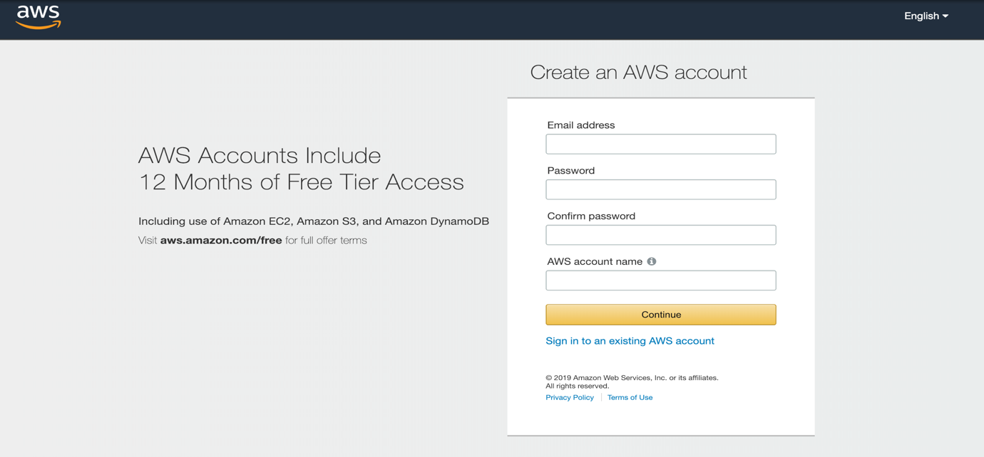

1. Register a thing in IoT Core Services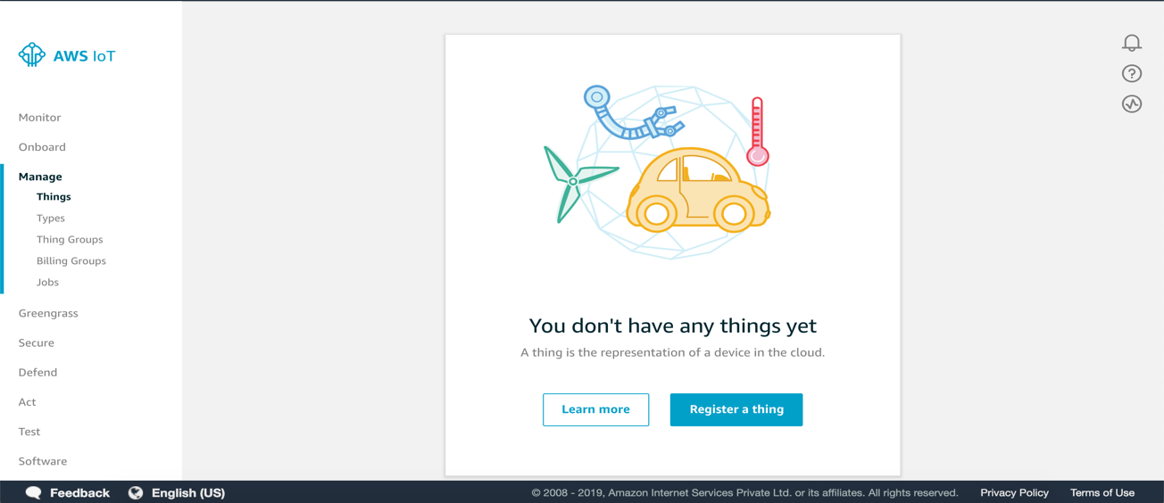
2. Create certificate and Activate it

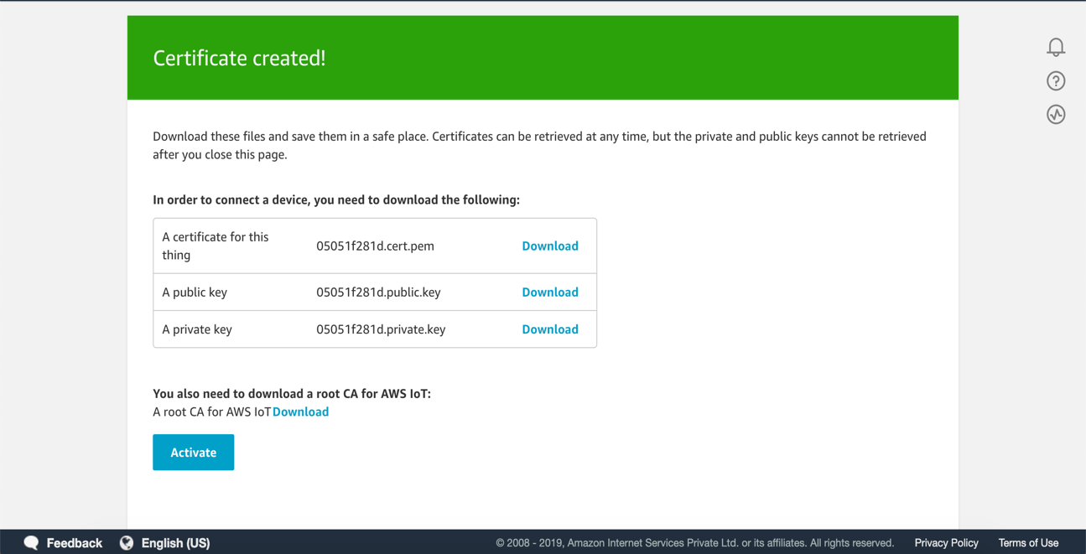

Note : Download the required certificates.

1. Go to IAM -> policies and search for AWSIoTFullAccess and copy the json code and paste it in IoT Core Policies Create a new policy and click on advanced and paste the code in it and click on create .

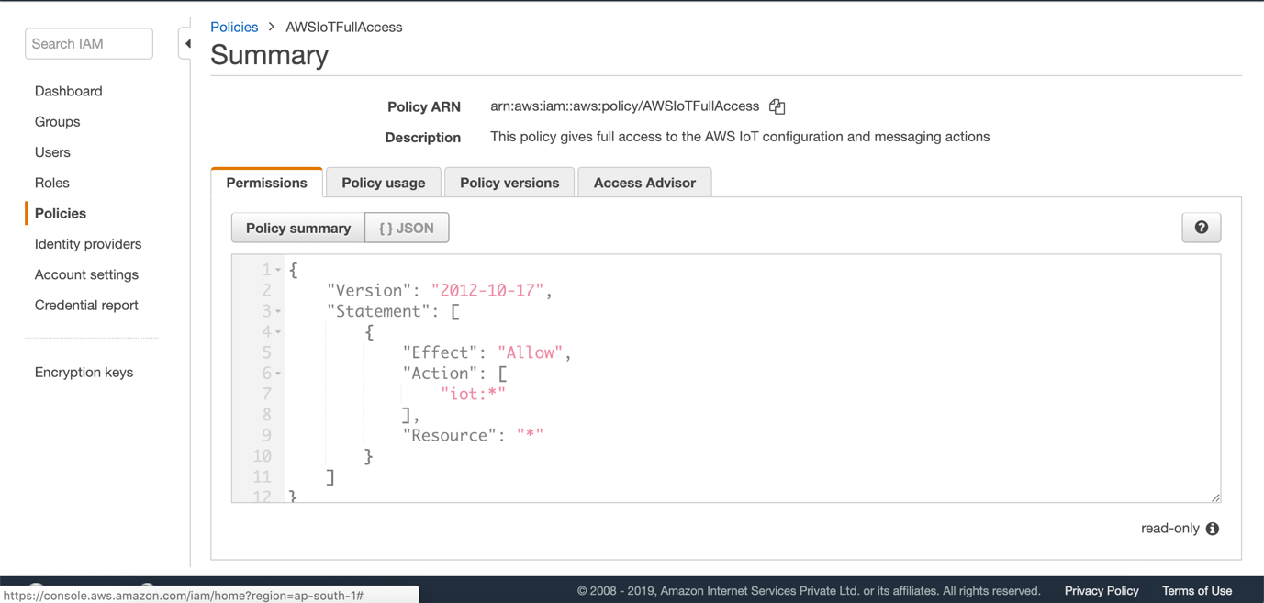

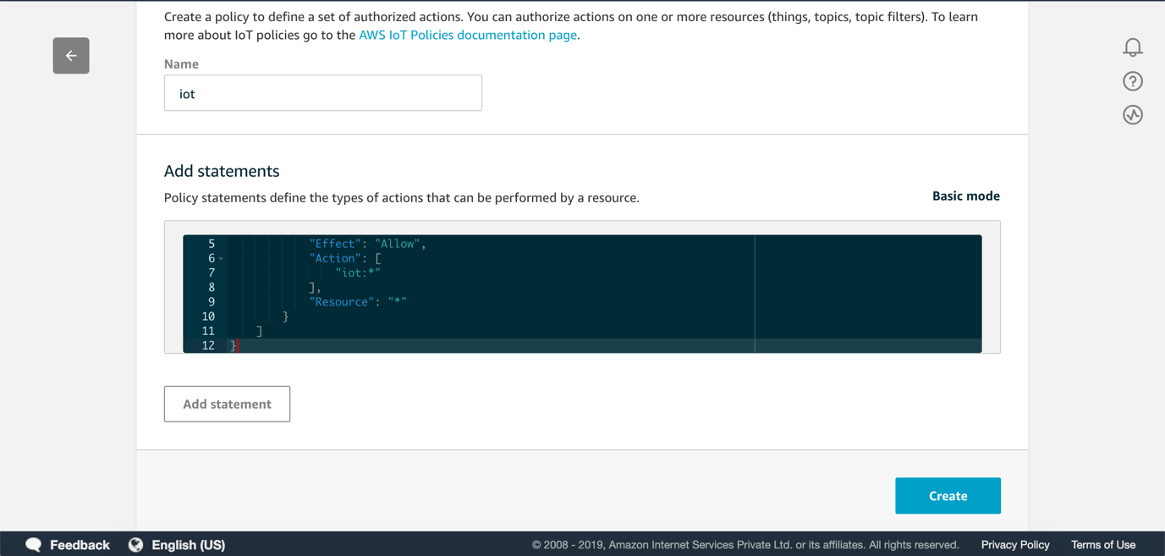

1. Now go to secure -> Certificates and attach the Policy & Thing which we created

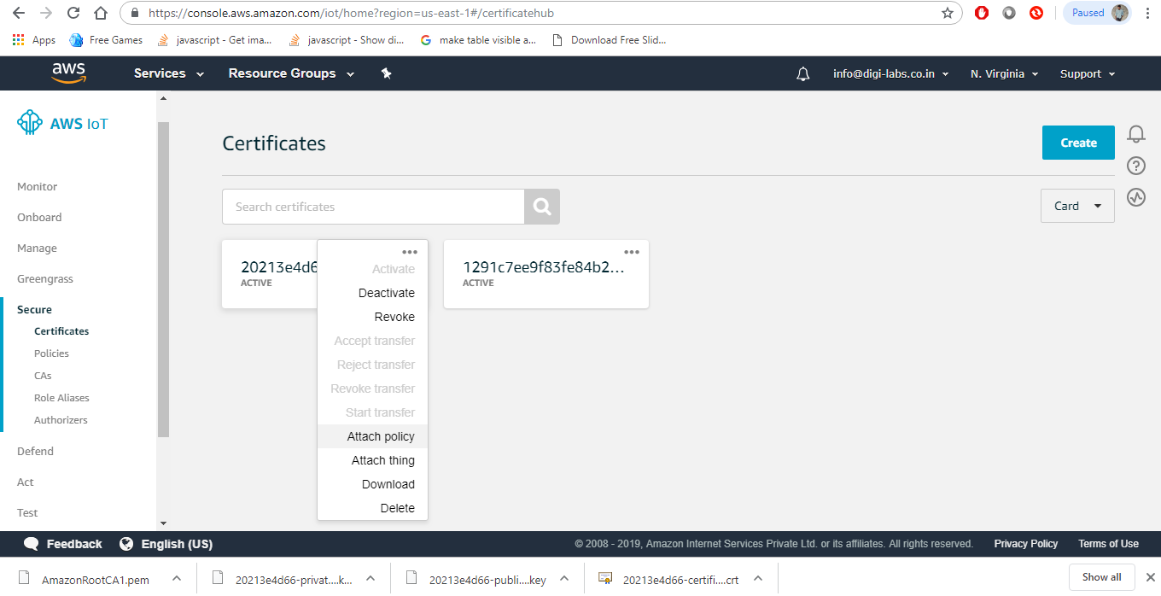

2. Setting up the Nodered Using mybluemix.net

Firstly, create a free account in mybluemix.net

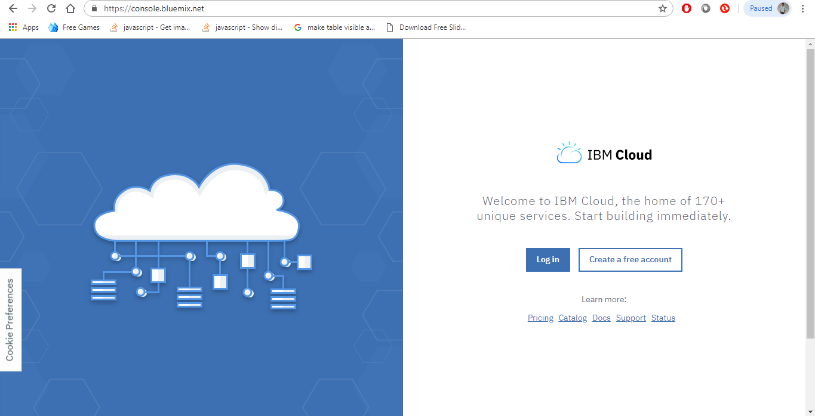

After signing in to the account. In the search box type node-RED

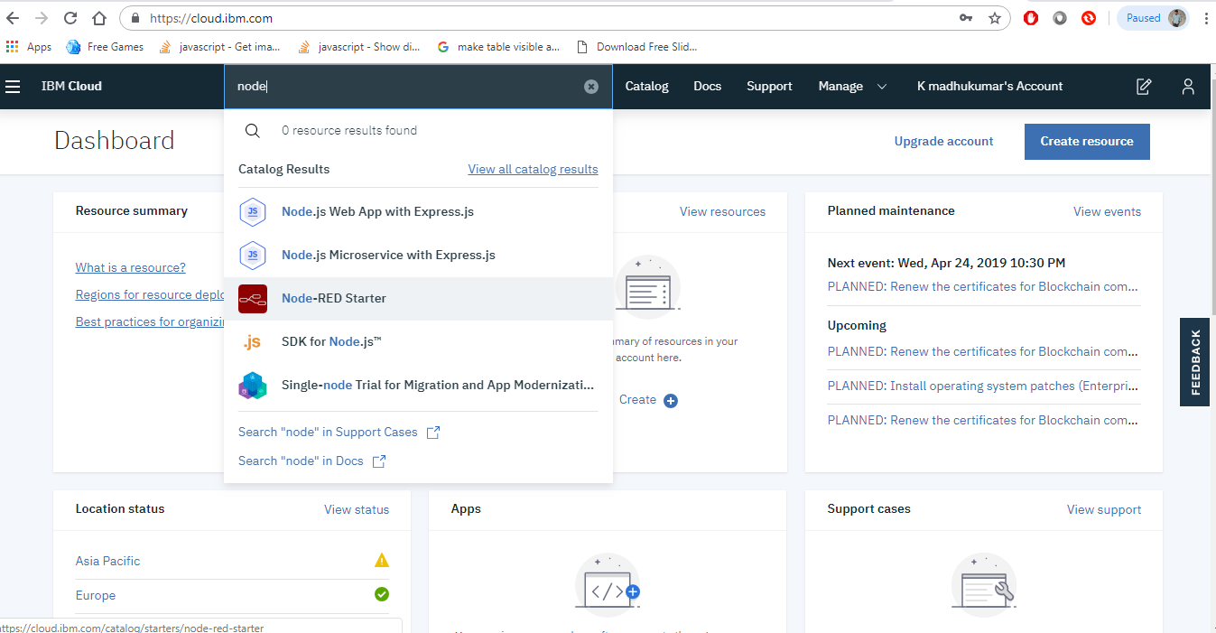

Then select the Node-RED starter from the list and fill the required fields and click on create as shown below

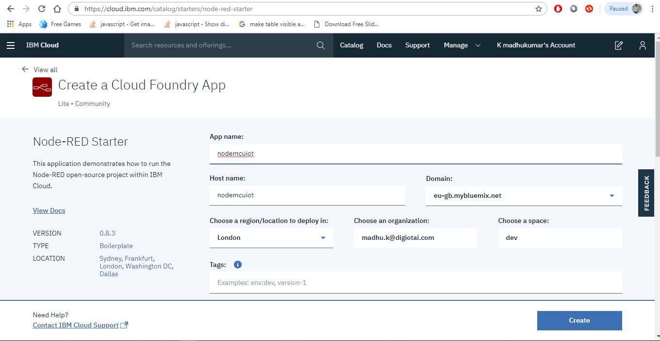

Then click on visit App Url as shown in below

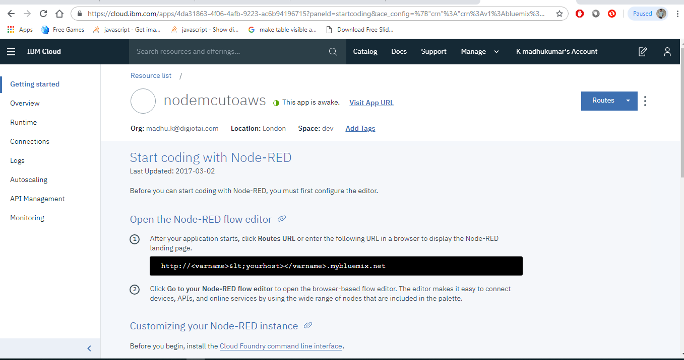

Then follow the steps and finish the process, then the following tab appears

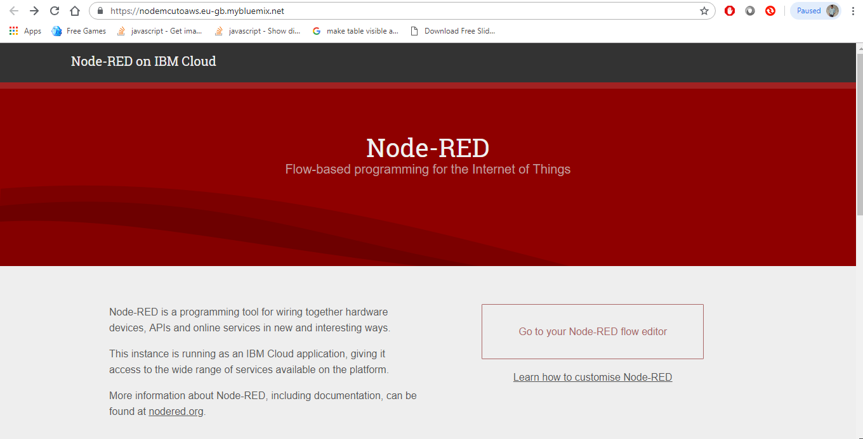

Now click on Go t your Node-RED flow editor

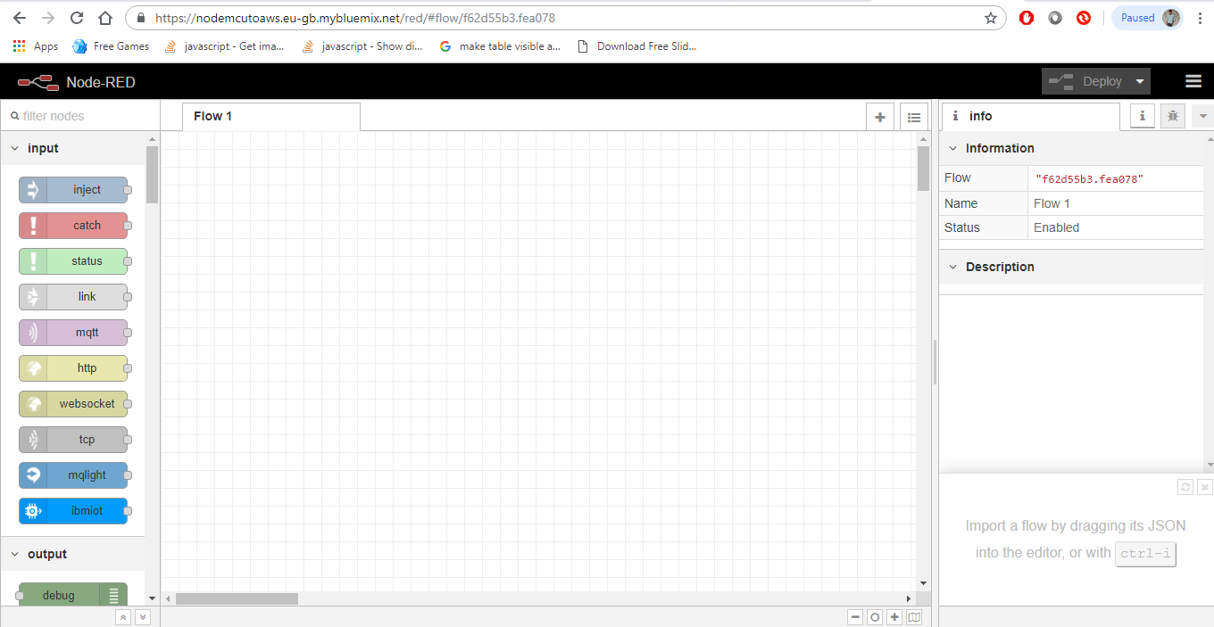

Then configure the connections as follow step by step:

Made the connections as shown in below

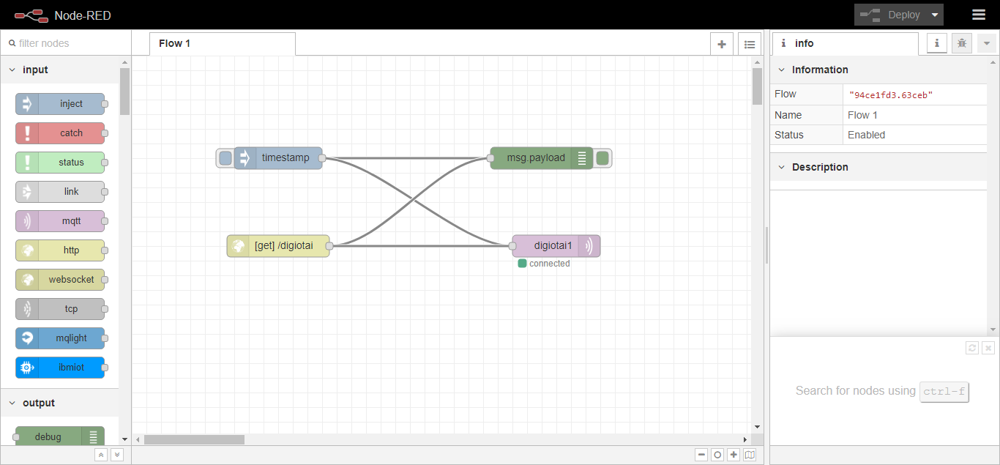

The configuration of Mqtt is shown below

First double click on mqtt then the following tab appears, then click on edit button as shown in below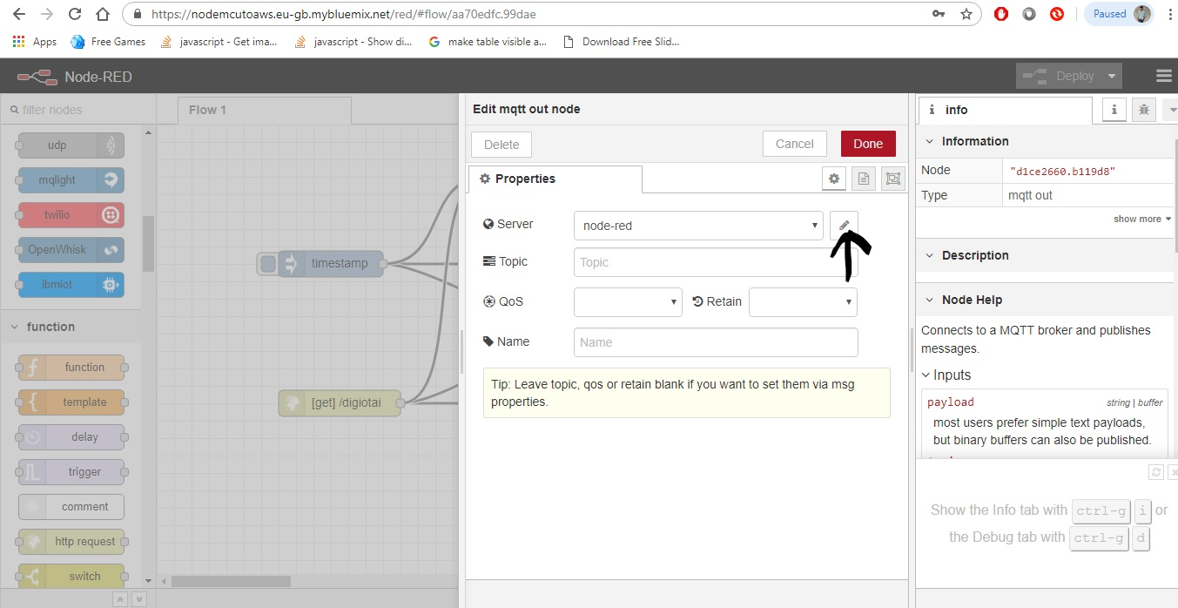

After clicking the edit button the following tab appears

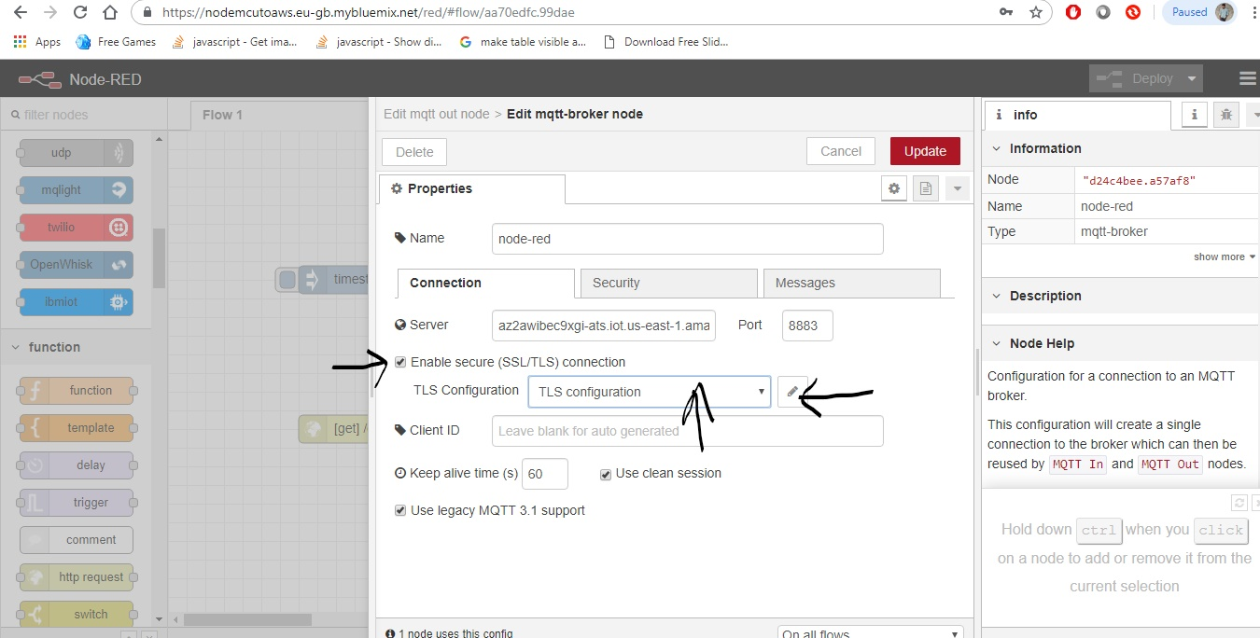

From the above tab first fill the name and server details. The server details are present in the settings in Amazon Web Services as shown in below

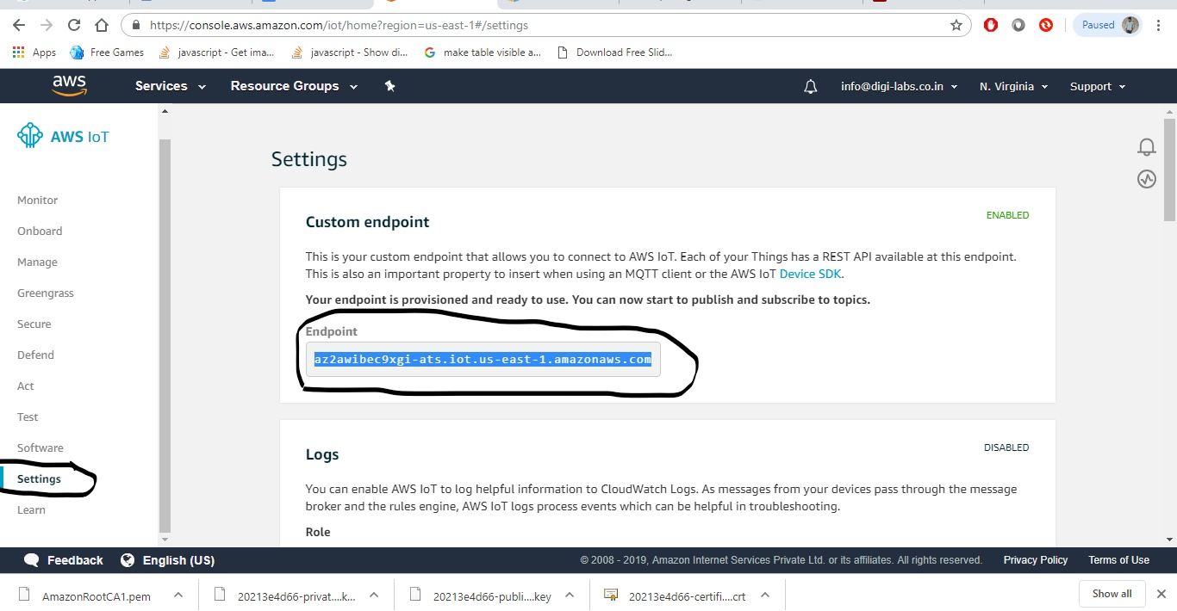

Now enable the “Enable secure (SSL/TLS) connection” and select the TLS Configuration and click on edit button as shown in above.

Then upload the certificates which is downloaded from the Amazon Web Services

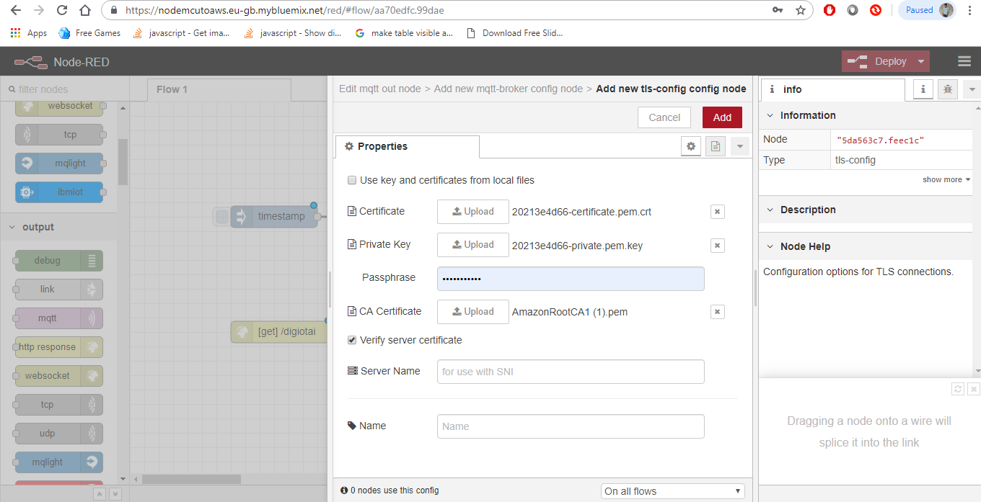

After completing the process don’t forget to click on Deploy Button

Setting up the s3 Bucket in AWS

First go to IoT Core -> Act -> create

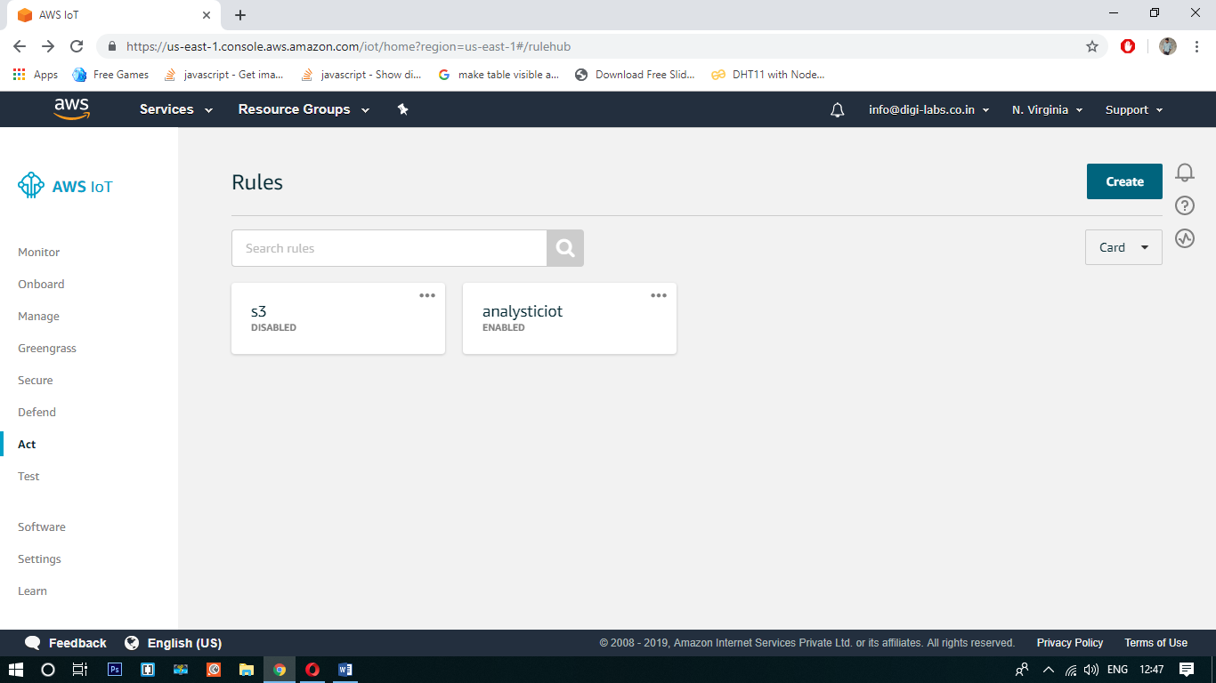

After click on create the following tab appears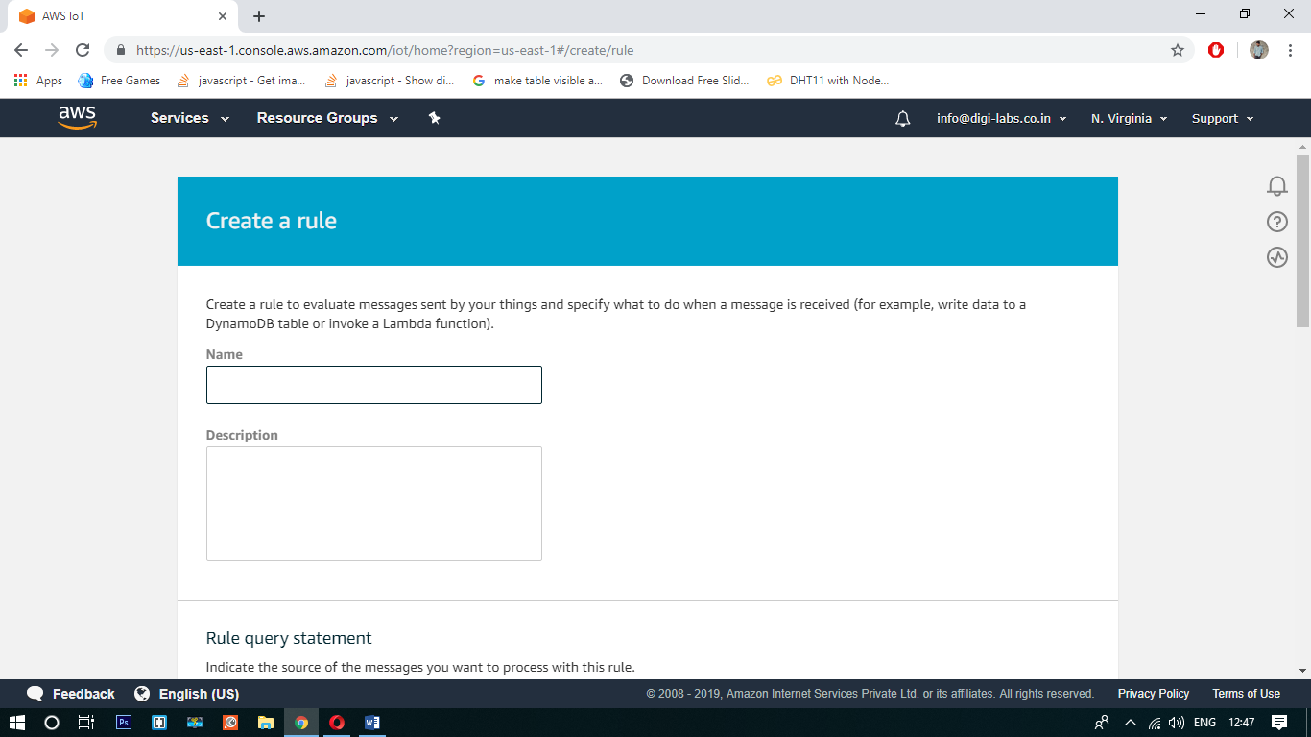

Give the Name & Description as you want, then scroll down and click on add action button as shown in below

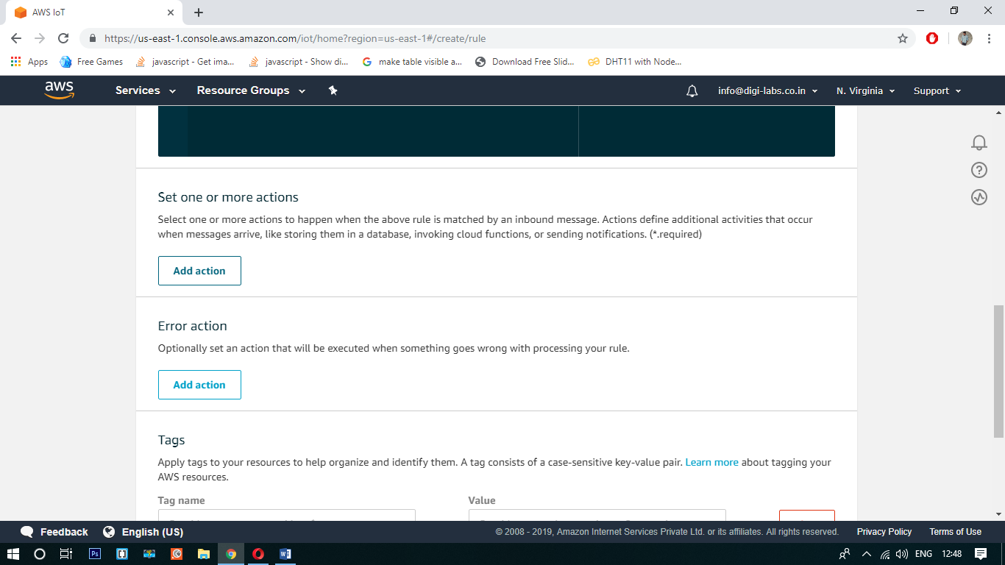

Once click on add action button the following tab appears

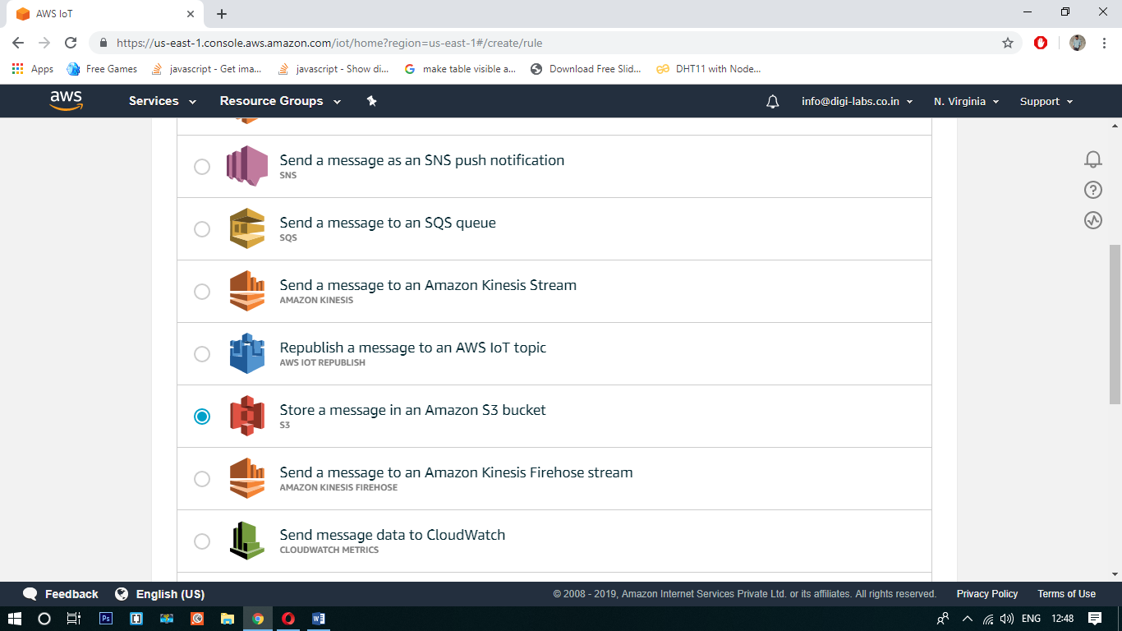

Then click on “store a message in an Amazon S3 buck” and click on configure action. Then the following appears

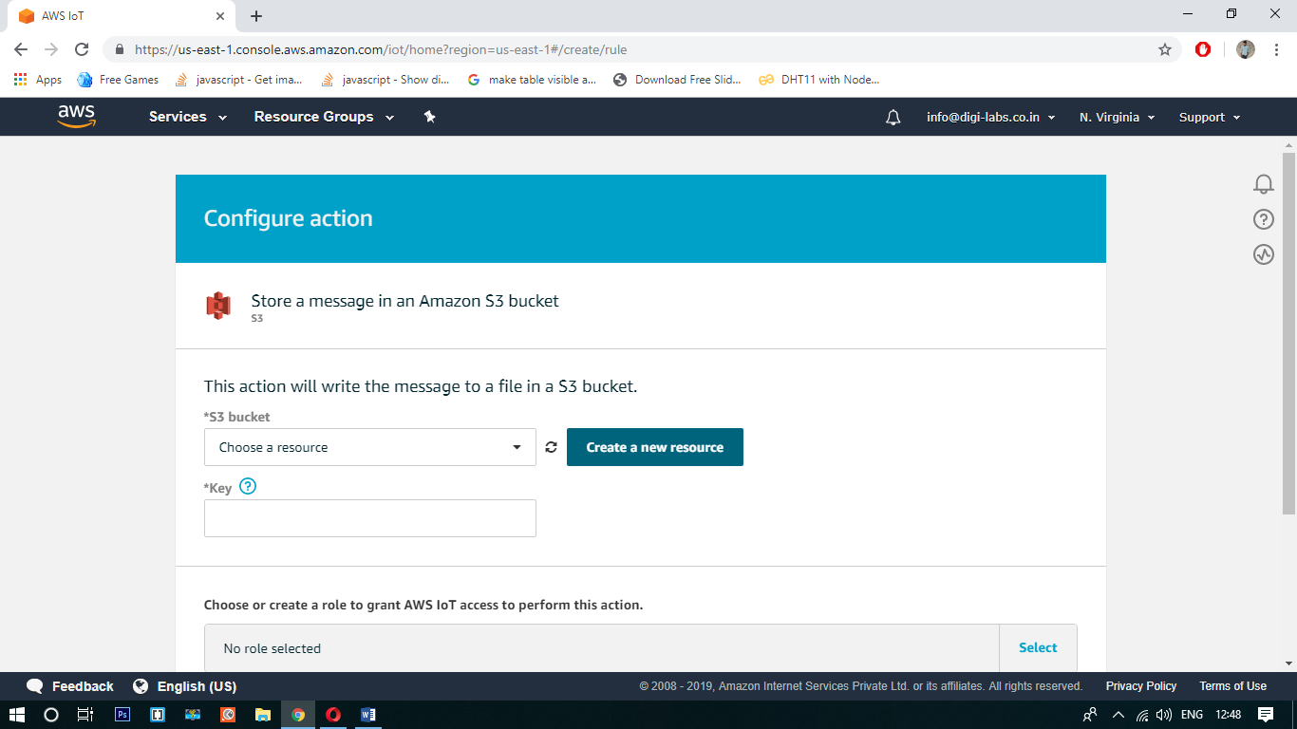

Now click on “create resource” and create a new resource

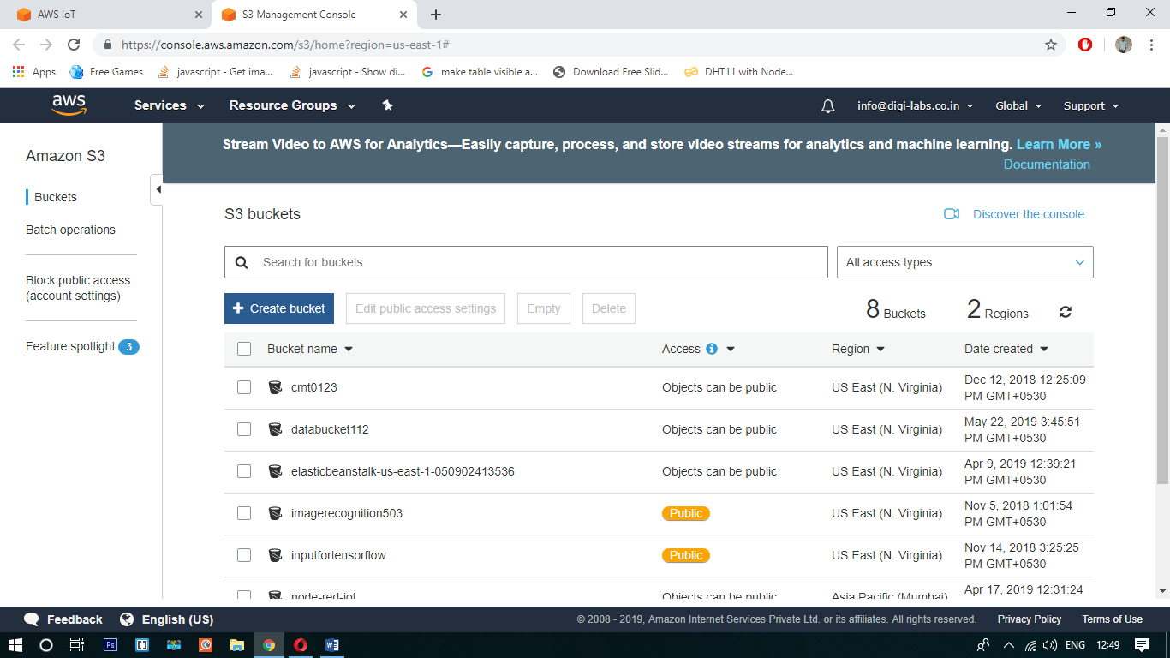

Here we have to create a bucket. Now click on “create bucket”

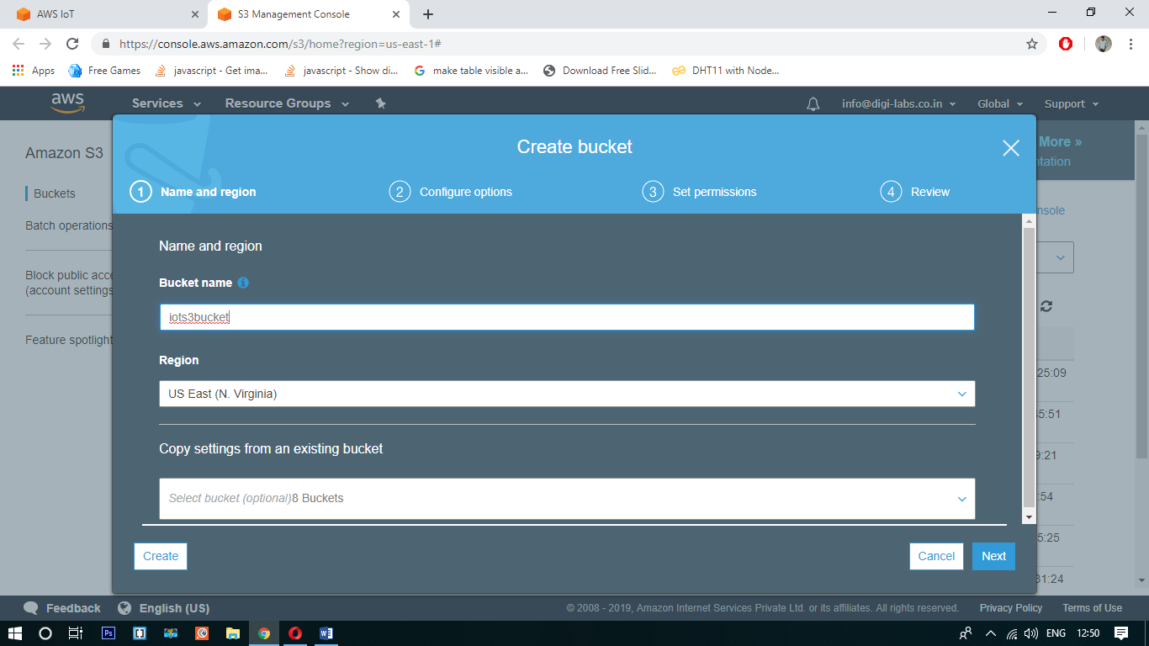

Fill the blanks and click on next

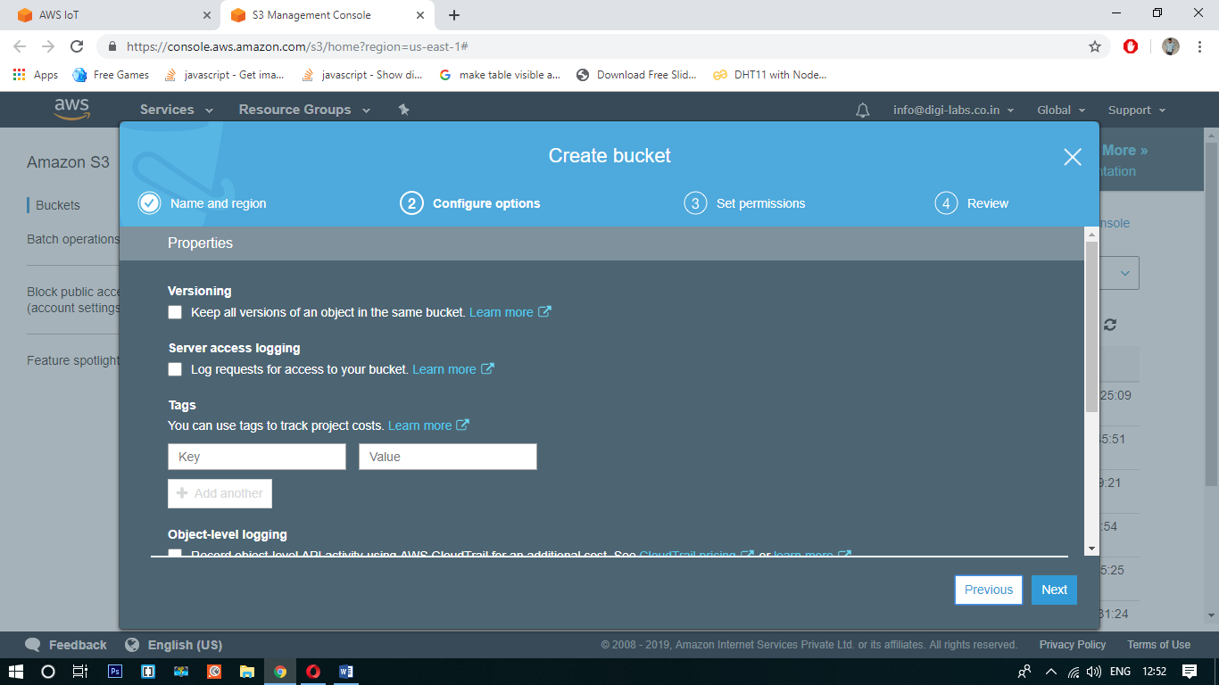

Again click on Next button

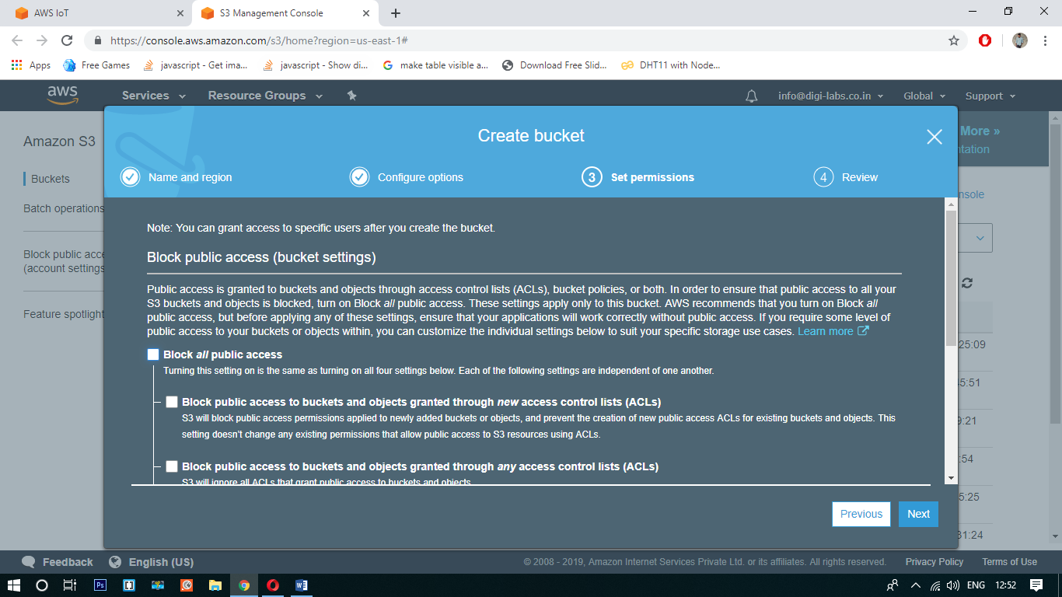

Here unmark the “Block Public Access” as shown in above then scroll down and change the permission as shown in below figure.

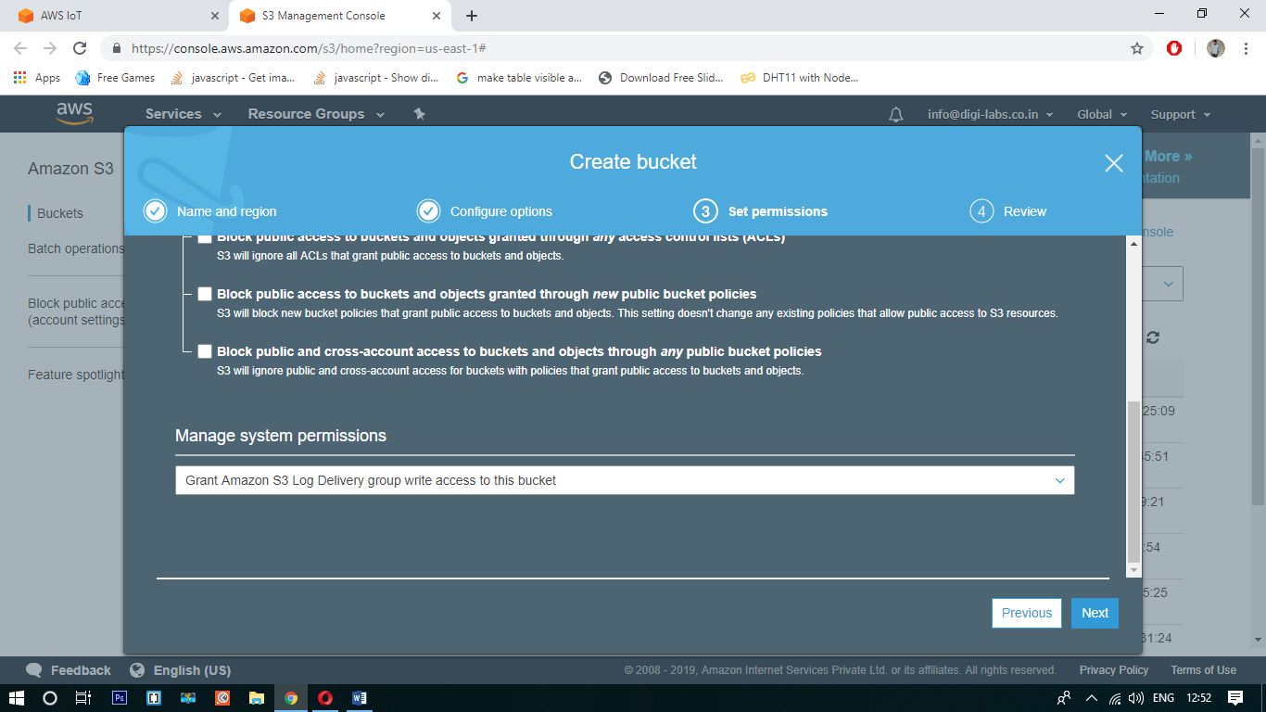

Then click on next

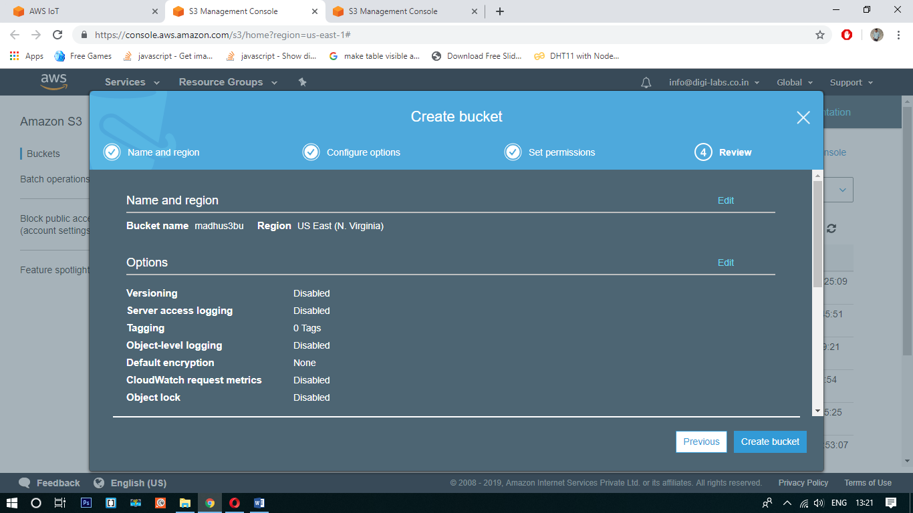

Then click on create bucket. After go to configuration tab and refresh it.

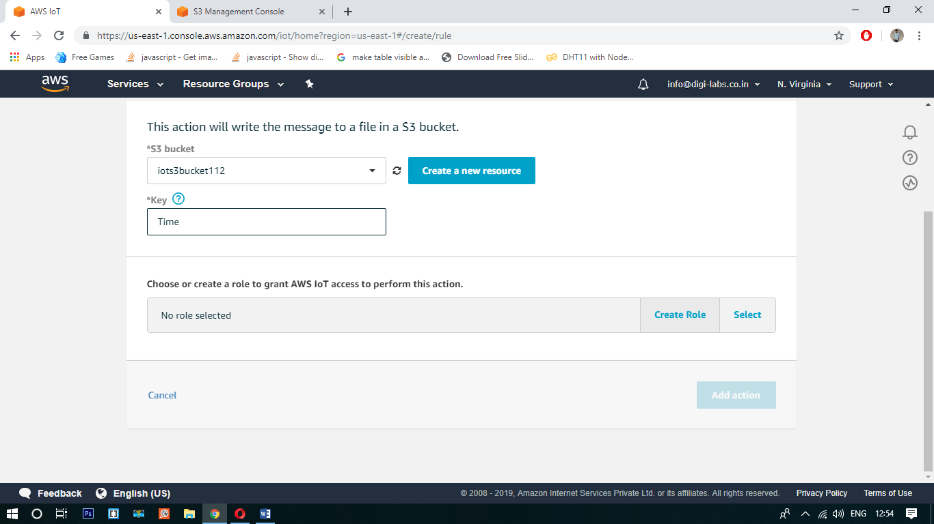

Here select the bucket what you have created.

Now click on create role and create and click on add action.

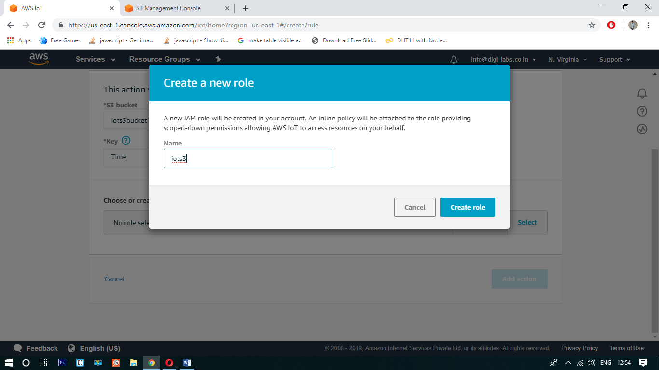

After click on add action add a rule query statement and click on create rule.

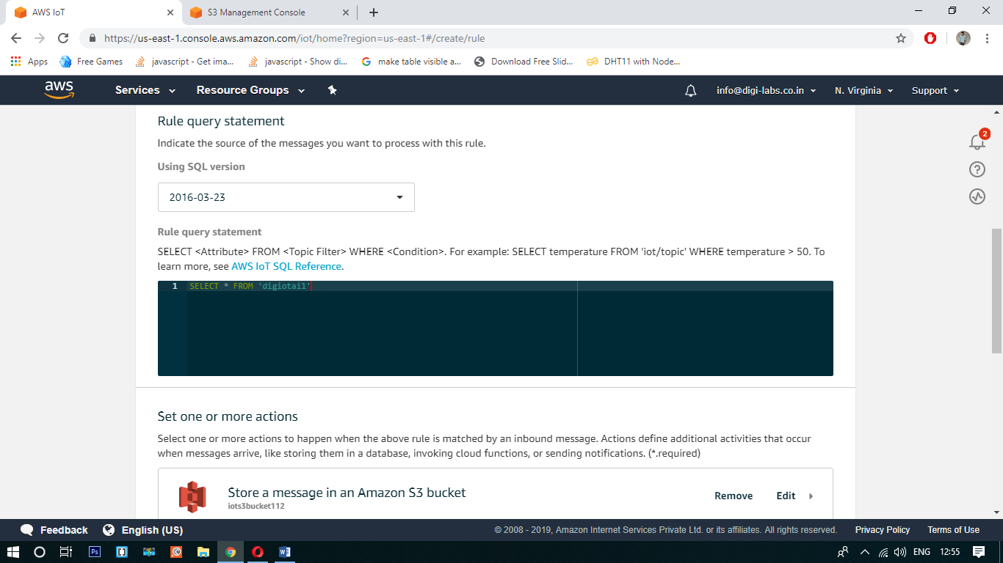

Format for Rule Query Statement is SELECT * FROM ‘digiotai1’.

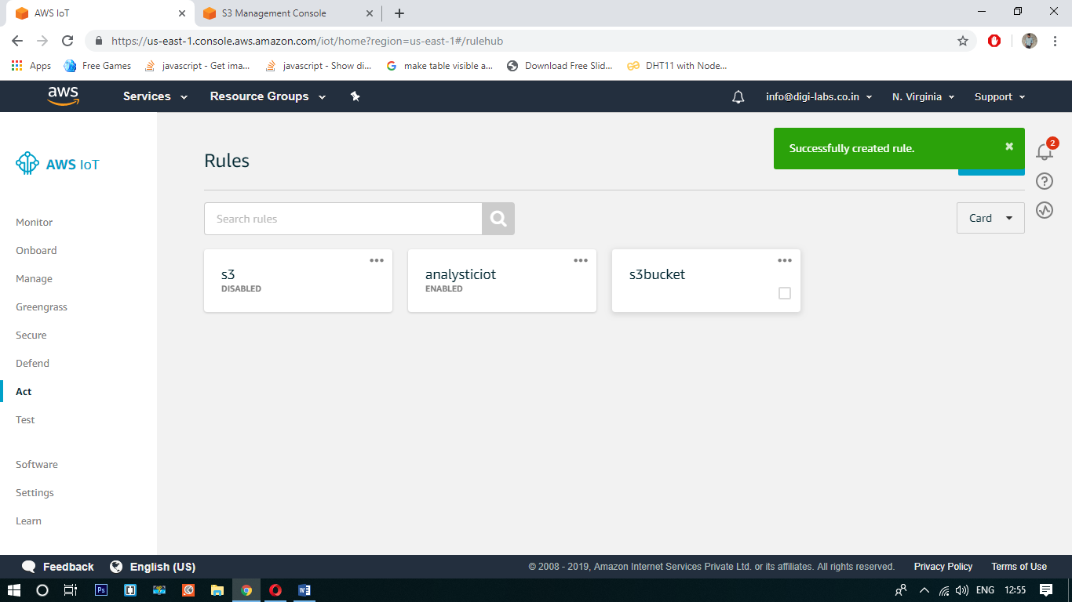

Before proceeding to next step make sure the rule is enabled or not.

Now open the Arduino ide write the program and connect the circuit.

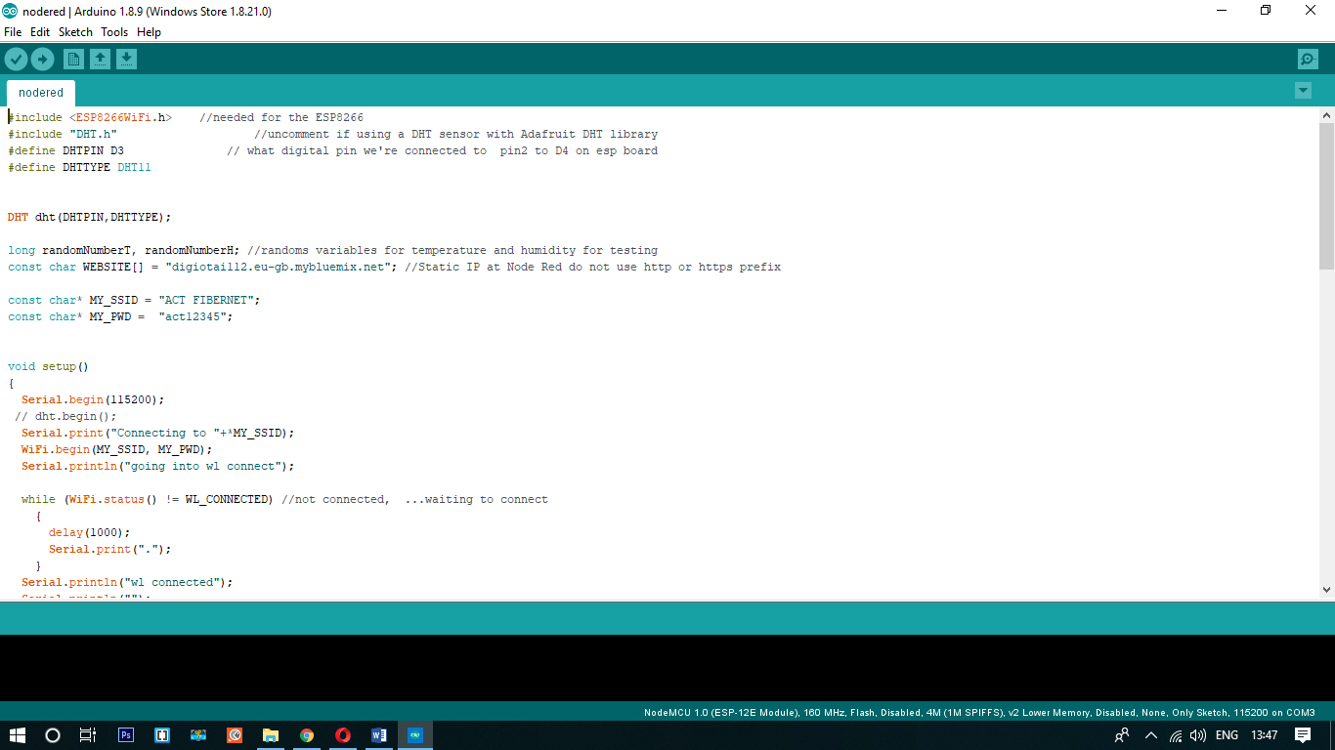

On another tab open Node Red Flow Editor.

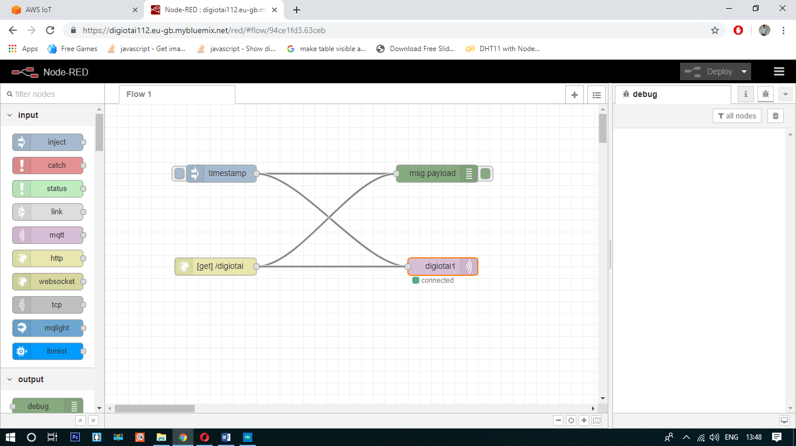

Now open the AWS IoT Core -> Test and subscribe to topic

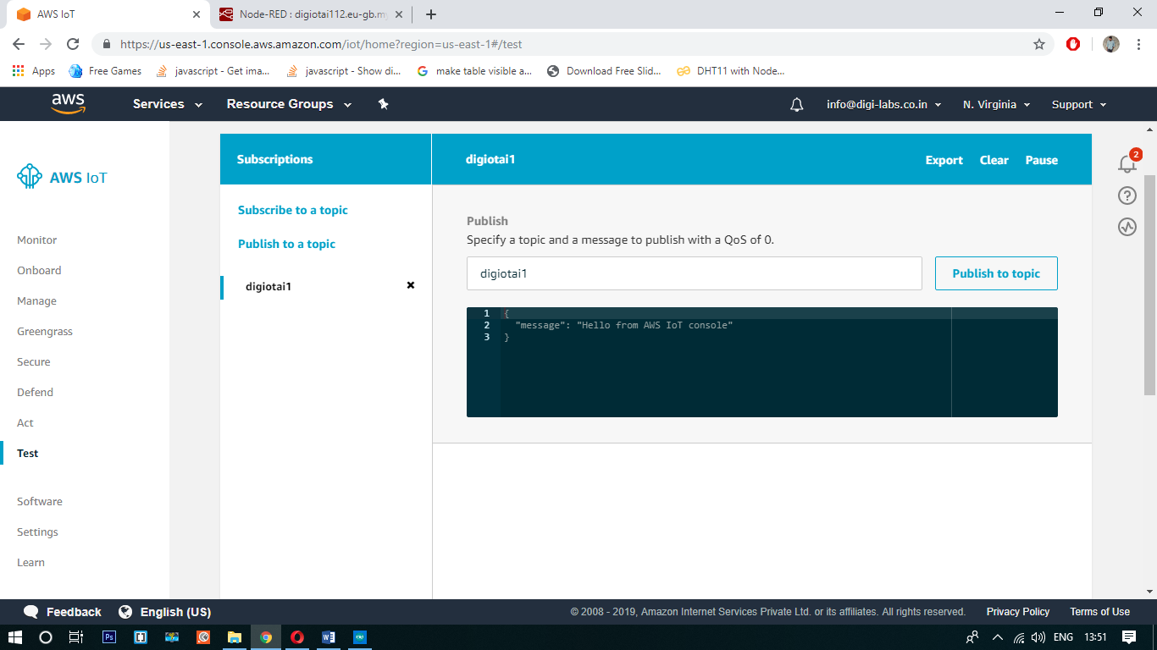

Now run the program and see the results as shown on below

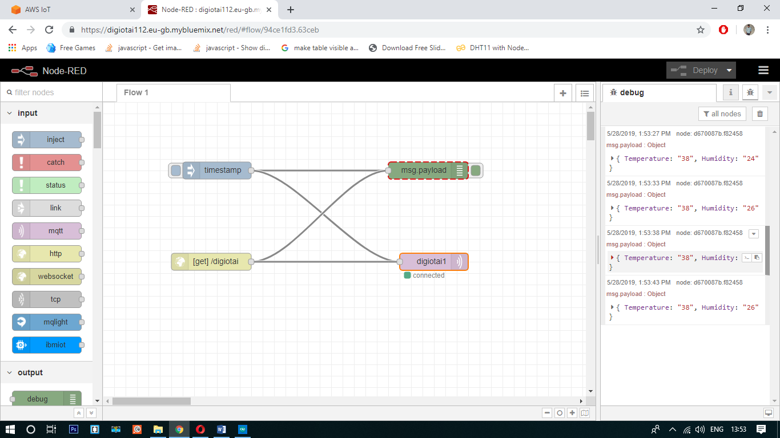

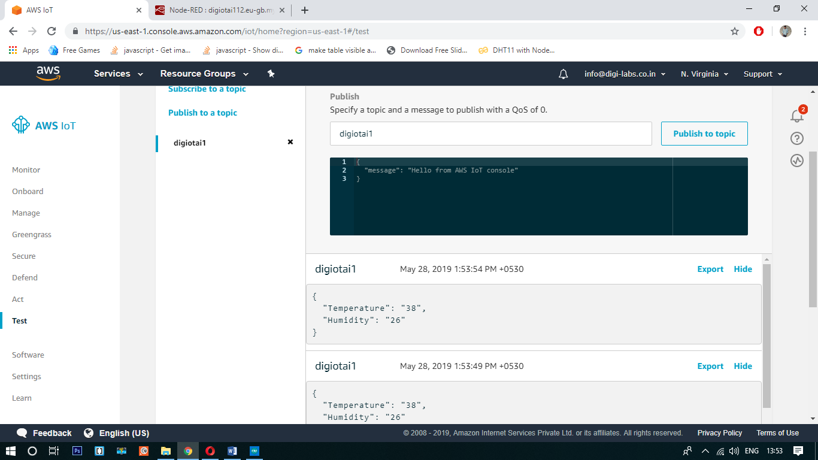

Now open the AWS S3 and download the output and open it

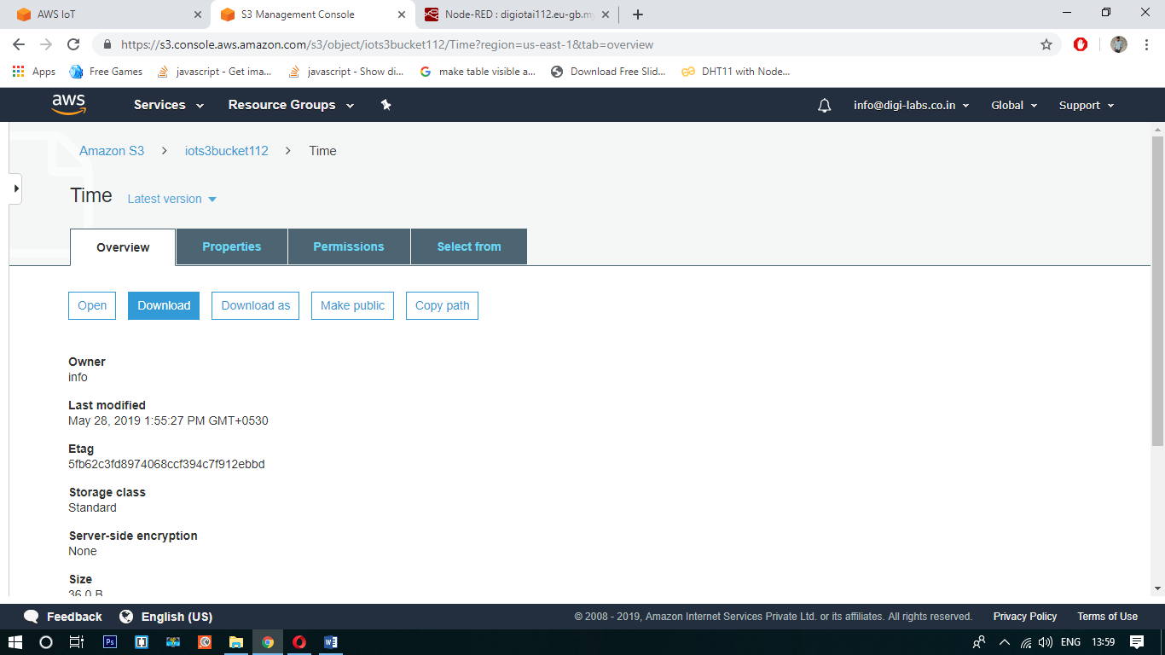

The final output is shown in below

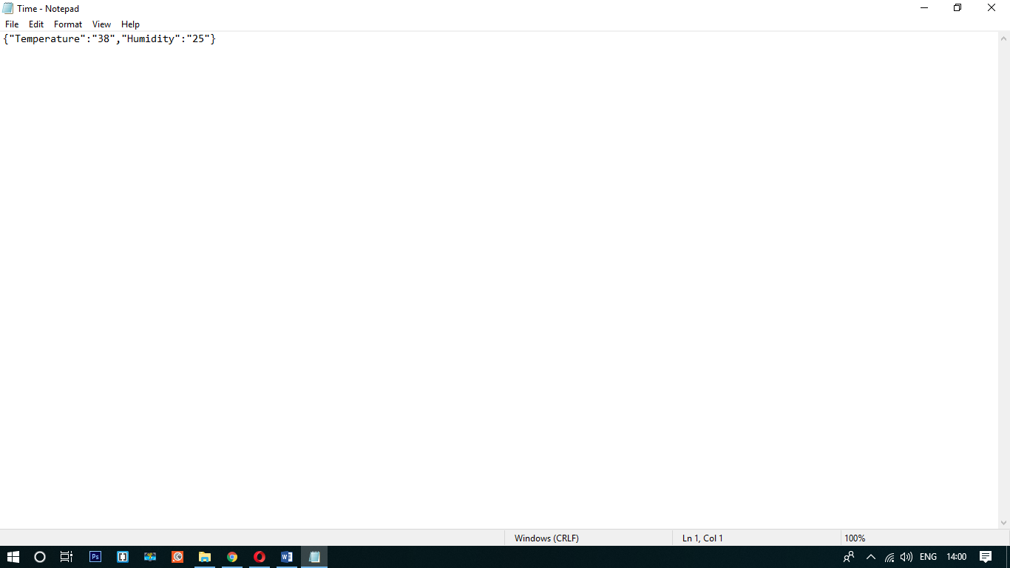

Here the main disadvantage in using S3 bucket is, it stores only one object at the time as shown in above.